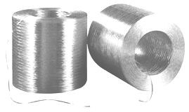
DIRECT ROVING

ACF-351

Taiwan Glass Ind. Corp.

PROPertieS

■ Very low fuzz
■ Fast wet out
■ Good processing characteristics
■ Low catenary
■ Good handling characteristics
■ High mechanical properties

ACF-351 Roving is an untwisted, single end roving, supplied as a tubeless package, for use in continuous process operations, such as weaving, pultrusion and filament winding. The sizing is specifically designed for fast wet out, good processing and handling characteristics as well as
excellent adhesion with most Polyester, Vinyl Ester and Epoxy resins.

SPECIFICATIONS

PACKAGING

Each individual cheese is contained within a transparent shrink wrap bag.

STORAGE

Our roving ACF-351 should be stored dry in its original packaging.
Storage temperature : 21+/-11 °C – Relative moisture : 60 +/-20%
Glass fiber products must remain in packaging material just prior to its use.
It is recommended to bring material in the working place 24 hours at least prior to use.
FRP Services Europe reserves the right to change the information given herein without prior notice. We believe this information to be reliable, but do not guarantee its applicability to the user’s process or assume liability for occurrence arising out of its use. The user, by accepting products described herein agrees to responsible for thoroughly testing any application before committing to production. JANUARY 2010

