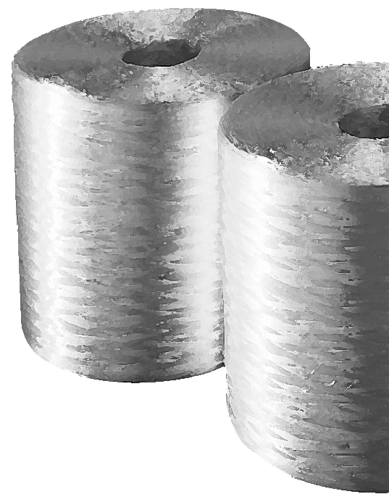
SMC ROVING

Taiwan Glass Ind. Corp.

PropERTIES

■ Excellent dispersion
■ Fast wet-out and wet-through
■ Low fly and fuzz
■ Low static
■ Easy chopping
■ High mechanical properties on moulded parts

SMC roving are a collection of specific numbers of continuous E-glass strands gathered together without mechanical twist, into single bundle and woundon to a cylindrical package.

spEcifications

Creel pack available on request

PACKAGING

STORAGE

SMC roving should be stored dry in its original packaging.
Storage temperature : max. 35 °C – Relative moisture : < 70 %
FRP Services Europe reserves the right to change the information given herein without prior notice. We believe this information to be reliable, but do not guarantee its applicability to the user’s process or assume liability for occurrence arising out of its use. The user, by accepting products described herein agrees to be responsible for thoroughly testing any application before committing to production. Avril 2018

