SINGLE YARN
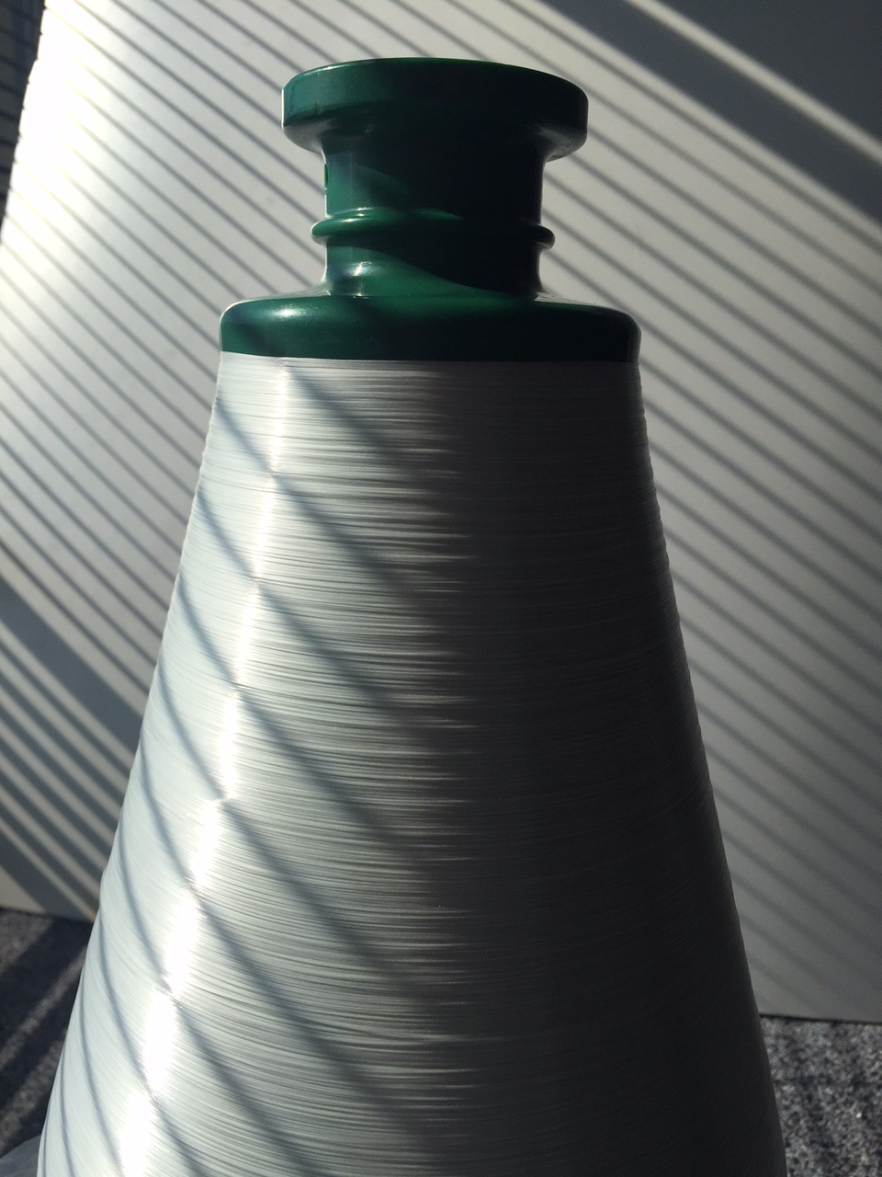



spécifications

PACKAGING

STORAGE

Our yarn should be stored dry in its original packaging.
Storage temperature : max. 35 °C – Relative moisture : < 70 %

FRP Services Europe reserves the right to change the information given herein without prior notice. We believe this information to be reliable, but do not guarantee its applicability to the user’s process or assume liability for occurrence arising out of its use. The user, by accepting products described herein agrees to responsible for thoroughly testing any application before committing to production.

. FRP SERVICES EUROPE .


BP 204 - 13796 Aix-en-Provence Cédex 3 - FRANCE
Tel : +33 (0)442 97 59 10 / Fax : +33 (0)442 97 59 20
e-mail : info@frpeufr.com

