
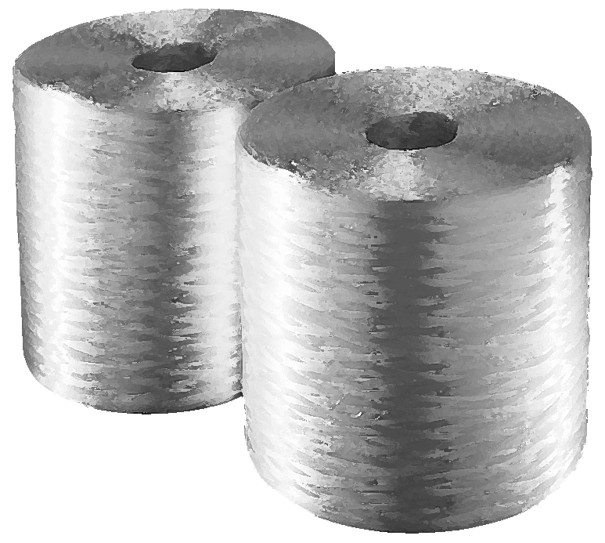

PropERTIES

■ Easy chopping
■ Good blade wear characteristics
■ Excellent run-out – Low fly and fuzz
■ Good laydown on mould
■ Good wet-out and wet-through
■ High mechanical properties on moulded parts

easygun® is made out of continuous E-glass strands, gathered without
mechanical twist. Each strand is made up of numerous glass filaments that
are bonded together with a polyester & vinylester compatible size.

spécifications

PACKAGING

STORAGE

easygun® should be stored dry in its original packaging.
Storage temperature : max. 35 °C – Relative moisture : < 70 %

FRP Services Europe reserves the right to change the information given herein without prior notice. We believe this information to be reliable, but do not guarantee its applicability to the user’s process or assume liability for occurrence arising out of its use. The user, by accepting products described herein agrees to be responsible for thoroughly testing any application before committing to production.

